HADOOP INSTALLING (in Pseudo distributed mode)

Version 1.0

Table des matières
HADOOP INSTALLING (in Pseudo distributed mode) 1
Version 1.0 1
I. Create and Setup SSH Certificates 5
II. Install Java 1.8 6
III. Hadoop v2.7.1 7
Hadoop Architecture 7
7
Hadoop Installation 8
Format the New Hadoop Filesystem 10
Starting Hadoop 10
Stopping Hadoop 10
HDFS commands 10
The MapReduce example : WordCount 11
IV. Apach Pig 0.16.0 12
Pig Architecture 12
Pig Installation 12
Pig commands 13
V. Hive 1.2.1 15
Hive Architecture 15
Hive Installation 16
Creating Hive warehouse directory 17
Configuring Hive 17
Downloading Apache Derby 18
Configuring Hive Metastore 18
Metastore schema initialization 18
Verifying Hive Installation by running Hive CLI 19
VI. Hbase 1.1.2 20
Storage Mechanism in HBase 20
HBase Architecture 20
Zookeeper Installation : 21
Start Zookeeper Server 21
Stop ZooKeeper Server 22
HBase Installation : 22
Starting HBase 23
HBase Shell 24
HBase Commands : 24
VII. Sqoop 1.4.6 26
Sqoop Architecture : 26
Sqoop Installation : 26
Mysql Install : 27
Sqoop Commands : 28
VIII. Flume 1.5.2 31
Flume Architecture : 31
Flume Agent : 32
Flume Installation : 32
Setup a Flume Agent : 33
Start the flume process 33
IX. Storm 0.10.0 34
Storm Architecture : 34
Storm Instalation : 35
Prerequisites 35
X. Apach Spark 2.2.0 37
Spark Components : 37
Spark Architecture : 37
Spark Instalation : 39
Step 1:Verifying Java Installation 39
Step 2: Downloading Apache Spark 39
Step 3: Installing Spark 39
Step 4: Verifying the Spark Installation 39
The Spark example : WordCount 40

About this Tutoriel :
Hadoop is an open-source framework that allows to store and process big data in a distributed environment across clusters of computers using simple programming models. It is designed to scale up from single servers to thousands of machines, each offering local computation and storage.
This brief tutorial provides a quick installation guide to Hadoop eco System.

Prerequisites :
Before proceeding with this tutorial, you need a basic knowledge of Core Java, Database concepts of SQL, Hadoop File system, and any of Linux operating system flavors.
You have to respect the Release version of the eco system hadoop to insure the compatibility of each component.
 | Java | Hadoop | Pig | Hive | Derby | Zookeeper | Hbase
Version | 1.8 | 2.7.1 | 0.16 | 1.2.1 | 10.13.X | 3.4.6 | 1.1.2

 | Sqoop | Flume | Storm | Spark | Scala
Version | 1.4.6 | 1.5.2 | 0.10.0 | 2.2.0 | 2.12.3

System : Centos 7 version 64 bits
Hardware :
- At least 4GB of RAM.
- CPU : i3.
Pseudo-distributed mode means that The eco system hadoop still runs completely on a single host, but each daemon (NameNode, DataNode, SecondaryNameNode, RessourceManager, HMaster, HRegionServer, and Zookeeper) runs as a separate process.

- Create and Setup SSH Certificates

SSH setup is required to do different operations on a cluster such as starting, stopping, distributed daemon shell operations. To authenticate different users of Hadoop, it is required to provide public/private key pair for a Hadoop user and share it with different users.
The following commands are used for generating a key value pair using SSH. Copy the public keys form id_rsa.pub to authorized_keys, and provide the owner with read and write permissions to authorized_keys file respectively.

$ ssh-keygen -t rsa

Generating public/private rsa key pair.
Enter file in which to save the key (/root/.ssh/id_rsa):
Enter passphrase (empty for no passphrase):
Enter same passphrase again:
Your identification has been saved in /root/.ssh/id_rsa.
Your public key has been saved in /root/.ssh/id_rsa.pub.
The key fingerprint is:
3a:0a:02:c0:73:5b:ab:10:cc:e0:04:7b:81:86:c1:8d root@vps448506.ovh.net
The key's randomart image is:
+--[ RSA 2048]----+
|B++ |
|XE o |
|+B.. . |
|..+ o . |
|.. . . S |
|. . . . |
|. .. o |
| . . . . |
| . |
+-----------------+

$ cat ~/.ssh/id_rsa.pub >> ~/.ssh/authorized_keys
$ chmod 0600 ~/.ssh/authorized_keys

- Install Java 1.8
This chapter explains the how to download, install, and set up JAVA in your system.
Java is the main prerequisite for Hadoop. First of all, you should verify the existence of java in your system using the command “java -version”. The syntax of java version command is given below.
$ java –version

If everything is in order, it will give you the following output.
java version "1.8.0_144"
Java(TM) SE Runtime Environment (build 1.8.0_144-b01)
Java HotSpot(TM) 64-Bit Server VM (build 25.144-b01, mixed mode)

If java is not installed in your system, then follow the steps given below for installing java.

Step 1
Download java :
$ wget "http://download.oracle.com/otn-pub/java/jdk/8u144b01/090f390dda5b47b9b721c7dfaa008135/jdk-8u144-linux-x64.tar.gz?AuthParam=1503679496_215798293c79dd0202a8efd47340bf2e"

Step 2
Generally you will find the downloaded java file in Downloads folder. Verify it and extract the jdk-7u71-linux-x64.gz file using the following commands.
$ tar –xzf jdk-8u144-linux-x64.tar.gz

Step 3
To make java available to all the users, you have to move it to the location “/usr/local/”. Open root, and type the following commands.
$ su
password:
$ mv jdk1.8.0_144 /usr/local/jdk1.8

Step 4
For setting up PATH and JAVA_HOME variables, add the following commands to ~/.bashrc.
export JAVA_HOME=/usr/local/jdk1.8
export PATH=$PATH:$JAVA_HOME/bin
Now apply all the changes into the current running system and verify the installtion.
$ source ~/.bashrc

- Hadoop v2.7.1
Hadoop is an Apache open source framework written in java that allows distributed processing of large datasets across clusters of computers using simple programming models. The Hadoop framework application works in an environment that provides distributed storage and computation across clusters of computers. Hadoop is designed to scale up from single server to thousands of machines, each offering local computation and storage.

Hadoop Architecture
At its core, Hadoop has two major layers namely:
- Processing/Computation layer (MapReduce), and
- Storage layer (Hadoop Distributed File System).
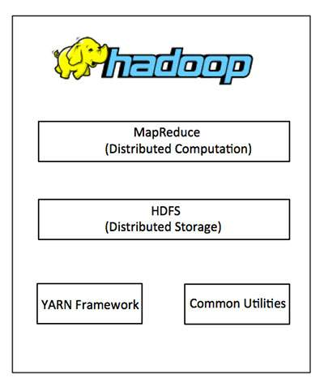

MapReduce
MapReduce is a parallel programming model for writing distributed applications devised at Google for efficient processing of large amounts of data (multiterabyte data-sets), on large clusters (thousands of nodes) of commodity hardware in a reliable, fault-tolerant manner. The MapReduce program runs on Hadoop which is an Apache open-source framework.
Hadoop Distributed File System
The Hadoop Distributed File System (HDFS) is based on the Google File System (GFS) and provides a distributed file system that is designed to run on commodity hardware. It has many similarities with existing distributed file systems. However, the differences from other distributed file systems are significant. It is highly fault-tolerant and is designed to be deployed on low-cost hardware. It provides high throughput access to application data and is suitable for applications having large datasets.
Apart from the above-mentioned two core components, Hadoop framework also includes the following two modules:
- Hadoop Common : These are Java libraries and utilities required by other Hadoop modules.
- Hadoop YARN : This is a framework for job scheduling and cluster resource management.

Hadoop Installation
This chapter explains the how to download, install, and set up Hadoop in your system.
Step 1
Download hadoop :
wget "https://archive.apache.org/dist/hadoop/core/hadoop-2.7.1/hadoop-2.7.1.tar.gz"

Step 2
Generally you will find the downloaded file in Downloads folder. Verify it and extract the hadoop-2.7.1.tar.gz file using the following commands.
$ tar –xzf hadoop-2.7.1.tar.gz

Step 3
To make java available to all the users, you have to move it to the location “/usr/local/”. Open root, and type the following commands.
$ su
password:
$ mv hadoop-2.7.1 /usr/local/hadoop/

Step 4
Setup configuration files
The following files will have to be modified to complete the Hadoop setup:
- ~/.bashrc
- /usr/local/hadoop/etc/hadoop/hadoop-env.sh
- /usr/local/hadoop/etc/hadoop/core-site.xml
- /usr/local/hadoop/etc/hadoop/mapred-site.xml.template
- /usr/local/hadoop/etc/hadoop/hdfs-site.xml

- ~/.bashrc:
Before editing the .bashrc file in our home directory, we need to find the path where Java has been installed to set the JAVA_HOME environment variable.
we can append the following to the end of ~/.bashrc

$ vi ~/.bashrc
#HADOOP VARIABLES START
export JAVA_HOME=/usr/local/jdk1.8
export HADOOP_INSTALL=/usr/local/hadoop
export PATH=$PATH:$HADOOP_INSTALL/bin
export PATH=$PATH:$HADOOP_INSTALL/sbin
export HADOOP_MAPRED_HOME=$HADOOP_INSTALL
export HADOOP_COMMON_HOME=$HADOOP_INSTALL
export HADOOP_HDFS_HOME=$HADOOP_INSTALL
export YARN_HOME=$HADOOP_INSTALL
export HADOOP_COMMON_LIB_NATIVE_DIR=$HADOOP_INSTALL/lib/native
export HADOOP_OPTS="-Djava.library.path=$HADOOP_INSTALL/lib"

- /usr/local/hadoop/etc/hadoop/hadoop-env.sh
We need to set JAVA_HOME by modifying hadoop-env.sh file.

$ vi /usr/local/hadoop/etc/hadoop/hadoop-env.sh
export JAVA_HOME=/usr/local/jdk1.8

Adding the above statement in the hadoop-env.sh file ensures that the value of JAVA_HOME variable will be available to Hadoop whenever it is started up.

- /usr/local/hadoop/etc/hadoop/core-site.xml:
The /usr/local/hadoop/etc/hadoop/core-site.xml file contains configuration properties that Hadoop uses when starting up.
Open the file and enter the following in between the <configuration></configuration> tag:
$ vi /usr/local/hadoop/etc/hadoop/core-site.xml
<configuration>
<property>
<name>fs.default.name</name>
<value>hdfs://localhost:9000</value>
<description>The name of the default file system. The uri's authority is used to determine the host, port, etc. for a filesystem.
</description>
</property>
</configuration>

- /usr/local/hadoop/etc/hadoop/mapred-site.xml
By default, the /usr/local/hadoop/etc/hadoop/ folder contains /usr/local/hadoop/etc/hadoop/mapred-site.xml.template file which has to be renamed/copied with the name mapred-site.xml:

$ cp /usr/local/hadoop/etc/hadoop/mapred-site.xml.template /usr/local/hadoop/etc/hadoop/mapred-site.xml

The mapred-site.xml file is used to specify which framework is being used for MapReduce.
<configuration>
<property>
<name>mapreduce.framework.name</name>
<value>yarn</value>
</property>
</configuration>

- /usr/local/hadoop/etc/hadoop/hdfs-site.xml
The hdfs-site.xml file contains information such as the value of replication data, namenode path, and datanode paths of your local file systems. It means the place where you want to store the Hadoop infrastructure.

<configuration>
<property>
<name>dfs.replication</name>
<value>1</value>
</property>
<property>
<name>dfs.name.dir</name>
<value>file:///home/hadoop/hadoopinfra/hdfs/namenode</value>
</property>
<property>
<name>dfs.data.dir</name>
<value>file:///home/hadoop/hadoopinfra/hdfs/datanode</value>
</property>
</configuration>

Note: In the above file, all the property values are user-defined and you can make changes according to your Hadoop infrastructure.

Format the New Hadoop Filesystem
Now, the Hadoop file system needs to be formatted so that we can start to use it. The format command should be issued with write permission since it creates current directory
under /home/hadoop/hadoopinfra/hdfs/namenode folder:

$ hdfs namenode -format

Note : that hdfs namenode -format command should be executed once before we start using Hadoop. If this command is executed again after Hadoop has been used, it'll destroy all the data on the Hadoop file system.

Starting Hadoop
We can use start-all.sh or (start-dfs.sh and start-yarn.sh)
The following command is used to start dfs. Executing this command will start your Hadoop file system.
$ start-dfs.sh
$ start-yarn.sh
We can check if it's really up and running:
$ jps
26737 DataNode
26899 SecondaryNameNode
26617 NameNode
27050 ResourceManager
27149 NodeManager

Stopping Hadoop
We run stop-all.sh or (stop-dfs.sh and stop-yarn.sh) to stop all the daemons running on our machine.

HDFS commands
The Hadoop command line environment is Linux-like. The Hadoop filesystem (fs) provides various shell commands to perform file operations such as copying file, viewing the contents of the file, changing ownership of files, changing permissions, creating directories, and so on.
The syntax of Hadoop fs shell command is as follows:
1. Create a directory in HDFS at given path(s).
• Usage:
hadoop fs -mkdir <paths>
• Example:
hadoop fs -mkdir /user/shiva/dir1 /user/shiva/dir2
2. List the contents of a directory.
• Usage:
hadoop fs -ls <args>
• Example:
hadoop fs -ls /user/shiva
3. Put and Get a file in HDFS.
• Usage(Put):
hadoop fs -put <localsrc> ... <HDFS_dest_Path>
• Example:
hadoop fs -put /home/shiva/Samplefile.txt /user/shiva/dir3/
• Usage(Get):
hadoop fs -get <hdfs_src> <localdst>
• Example:
hadoop fs -get /user/shiva/dir3/Samplefile.txt /home/
4. See contents of a file
• Usage:
hadoop fs -cat <path[filename]>

The MapReduce example : WordCount
Compile WordCount.java and create a jar.
$ javac WordCount.java // compile
$ jar -cvf wc.jar WordCount.class // create a a jar file
$ hadoop jar wc.jar WordCount /user/shiva/sample.txt /user/shiva/output //import any file that contains words to count sample.txt as input file
And it will generate a file part-r-00000 under output that contains the words counted
$ hadoop fs -cat /user/cloudera/wordcount/output/*
Hadoop 3
Oh 1
a 1
an 1
as 2
be 1
can 1
elephant 1
fellow 1
is 3
what 1
yellow 2
$ hadoop fs -rm -r /user/cloudera/wordcount/output //If you want to run the sample again, you first need to remove the output directory. Use the following command.

- Apach Pig 0.16.0
Apache Pig is an abstraction over MapReduce. It is a tool/platform which is used to analyze larger sets of data representing them as data flows. Pig is generally used with Hadoop; we can perform all the data manipulation operations in Hadoop using Apache Pig.
To analyze data using Apache Pig, programmers need to write scripts using Pig Latin language. All these scripts are internally converted to Map and Reduce tasks. Apache Pig has a component known as Pig Engine that accepts the Pig Latin scripts as input and converts those scripts into MapReduce jobs.

Pig Architecture
The language used to analyze data in Hadoop using Pig is known as Pig Latin. It is a highlevel data processing language which provides a rich set of data types and operators to perform various operations on the data.
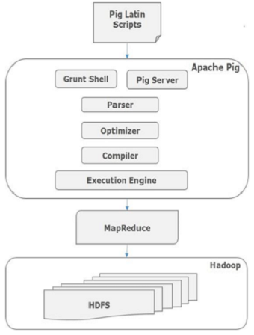
To perform a particular task Programmers using Pig, programmers need to write a Pig script using the Pig Latin language, and execute them using any of the execution mechanisms (Grunt Shell, UDFs, Embedded). After execution, these scripts will go through a series of transformations applied by the Pig Framework, to produce the desired output.
Internally, Apache Pig converts these scripts into a series of MapReduce jobs, and thus, it makes the programmer’s job easy. The architecture of Apache Pig is shown below.

Pig Installation

This chapter explains the how to download, install, and set up Apache Pig in your system.

Prerequisites
It is essential that you have Hadoop and Java installed on your system before you go for Apache Pig. Therefore, prior to installing Apache Pig, install Hadoop and Java by following the steps given above .

Step 1
Download pig :
wget "http://www-eu.apache.org/dist/pig/pig-0.16.0/pig-0.16.0.tar.gz"

Step 2
Generally you will find the downloaded file in Downloads folder. Verify it and extract the pig-0.16.0.tar.gz file using the following commands.
$ tar –xzf pig-0.16.0.tar.gz

Step 3
To make pig available to all the users, you have to move it to the location “/usr/local/”. Open root, and type the following commands.
$ su
password:
$ mv pig-0.16.0 /usr/local/pig/

Step 4
For setting up PATH, PIG_HOME and PIG_CLASSPATH variables, add the following commands to ~/.bashrc file.
PIG_HOME folder to the Apache Pig’s installation folder
PATH environment variable to the bin folder
PIG_CLASSPATH environment variable to the etc (configuration) folder of your Hadoop installations (the directory that contains the core-site.xml, hdfs-site.xml and mapred-site.xml files).
export PIG_HOME=/usr/local/pig
export PATH=$PATH:$PIG_HOME/bin
export PIG_CLASSPATH=$HADOOP_HOME/conf
Now apply all the changes into the current running system.
$ source ~/.bashrc
Now verify the installation using the command pig -version from the terminal as explained above.

Pig commands

// Loading data
movies = LOAD '/user/biadmin/shiva/movies_data.csv' USING PigStorage(',') as (id,name,year,rating,duration);
// View the data
DUMP movies;
// Limit records
movies_limit_10 = LIMIT movies 10;
DUMP movies_limit_10;
//ForEach Generate Example
movie_duration = FOREACH movies GENERATE name,(double)(duration/60);
// Filter Example
movies_greater_than_four = FILTER movies BY (float)rating>4.0;
movies_greater_than_four_and_2012 = FILTER movies BY (float)rating>4.0 AND year > 2012;
// Group By
grouped_by_year = group movies by year;

// Aggregation Example
count_by_year = FOREACH grouped_by_year GENERATE group, COUNT(movies);
Cogroup Example
owners = LOAD 'owners.csv' USING PigStorage(',') AS (owner:chararray,animal:chararray);
pets = LOAD 'pets.csv' USING PigStorage(',') AS (name:chararray,animal:chararray);
grouped = COGROUP owners BY animal, pets by animal;
DUMP grouped;
// Describe Example
Describe grouped;
// Explain Example
explain grouped;
// Illustrate Example
illustrate grouped;

- Hive 1.2.1
Hive is a data warehouse infrastructure tool to process structured data in Hadoop. It resides on top of Hadoop to summarize Big Data, and makes querying and analyzing easy.

Hive Architecture
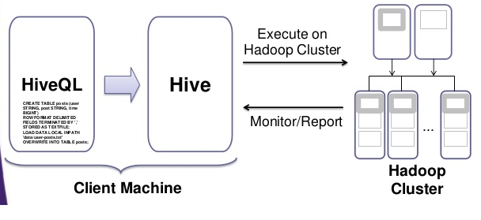
Physical Architecture

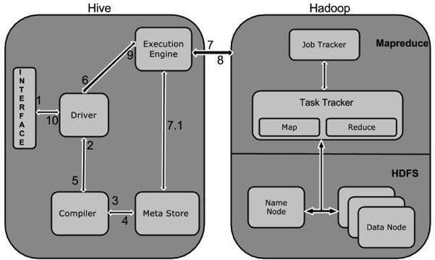
Logic Architecture

The following table defines how Hive interacts with Hadoop framework:
Step No. | Operation
1 Execute Query | The Hive interface such as Command Line or Web UI sends query to Driver (any database driver such as JDBC, ODBC, etc.) to execute.
2 Get Plan | The driver takes the help of query compiler that parses the query to check the syntax and query plan or the requirement of query.
3 Get Metadata | The compiler sends metadata request to Metastore (any database).
4 Send Metadata | Metastore sends metadata as a response to the compiler.
5 Send Plan | The compiler checks the requirement and resends the plan to the driver. Up to here, the parsing and compiling of a query is complete.
6 Execute Plan | The driver sends the execute plan to the execution engine.
7 Execute Job | Internally, the process of execution job is a MapReduce job. The execution engine sends the job to JobTracker, which is in Name node and it assigns this job to TaskTracker, which is in Data node. Here, the query executes MapReduce job.
7.1 Metadata Ops | Meanwhile in execution, the execution engine can execute metadata operations with Metastore.
8 Fetch Result | The execution engine receives the results from Data nodes.
9 Send Results | The execution engine sends those resultant values to the driver.
10 Send Results | The driver sends the results to Hive Interfaces.

Hive Installation
Prerequisites
It is essential that you have Hadoop and Java installed on your system before you go for Apache Hive. Therefore, prior to installing Apache Hive, install Hadoop and Java by following the steps given above
Step 1
Download Hive :
wget "https://archive.apache.org/dist/hive/hive-1.2.1/apache-hive-1.2.1-bin.tar.gz"

Step 2
Generally you will find the downloaded file in Downloads folder. Verify it and extract the apache-hive-1.2.1-bin.tar.gz file using the following commands.
$ tar –xzf apache-hive-1.2.1-bin.tar.gz

Step 3
To make hive available to all the users, you have to move it to the location “/usr/local/”. Open root, and type the following commands.
$ su
password:
$ mv apache-hive-1.2.1-bin /usr/local/hive/

Step 4
Open ~/.bashrc and set the environment variable HIVE_HOME to point to the installation directory and PATH:
export HIVE_HOME=/usr/local/hive
export HIVE_CONF_DIR=/usr/local/hive/conf
export PATH=$PATH :$HIVE_HOME/bin
export CLASSPATH=$CLASSPATH:/usr/local/hadoop/lib/*:.
export CLASSPATH=$CLASSPATH:/usr/local/hive/lib/*:.

Now apply all the changes into the current running system.

$ source ~/.bashrc

Creating Hive warehouse directory

Hive uses Hadoop, so we must have Hadoop in our path. In addition, we must use below HDFS commands to create /tmp and /user/hive/warehouse and set them chmod g+w before we can create a table in Hive:
$ hadoop fs –mkdir tmp
$ hadoop fs –chmod g+w /tmp
$ hadoop fs –mkdir /user/shiva/warehouse
$ hadoop fs –chmod g+w /user/shiva/warehouse

The directory warehouse is the location to store the table or data related to hive, and the temporary directory tmp is the temporary location to store the intermediate result of processing.

Configuring Hive
To configure Hive with Hadoop, we need to edit the hive-env.sh file, which is placed in the $HIVE_HOME/conf directory. The following commands redirect to Hive conf folder and copy the template file:
$ cd $HIVE_HOME/conf
$ cp hive-env.sh.template hive-env.sh

Edit the hive-env.sh file by appending the following line:
export HADOOP_HOME=/usr/local/hadoop

Hive installation is completed successfully. Now we need an external database server to configure Metastore. We use Apache Derby database.

Downloading Apache Derby
The following command is used to download , install and setup Apache Derby :
$ wget http://archive.apache.org/dist/db/derby/db-derby-10.13.1.1/db-derby-10.13.1.1-bin.tar.gz
$ tar –xzf db-derby-10.13.1.1-bin.tar.gz
$ mv db-derby-10.13.1.1-bin /usr/local/derby

Let's set up the Derby environment by appending the following lines to ~/.bashrc file:
export DERBY_HOME=/usr/local/derby
export PATH=$PATH:$DERBY_HOME/bin
export CLASSPATH=$CLASSPATH:$DERBY_HOME/lib/derby.jar:$DERBY_HOME/lib/derbytools.jar

We need to create a directory named data in $DERBY_HOME directory to store Metastore data
mkdir $DERBY_HOME/data
Now we completed Derby installation and environmental setup.

Configuring Hive Metastore
Configuring Metastore means specifying to Hive where the database is stored. We want to do this by editing the hive-site.xml file, which is in the $HIVE_HOME/conf directory. Let's copy the template file using the following command:
$ cd $HIVE_HOME/conf
$ cp hive-default.xml.template hive-site.xml

Make sure the following lines are between the <configuration> and </configuration> tags of hive-site.xml:
<property>
<name>javax.jdo.option.ConnectionURL</name> . <value>jdbc:derby:;databaseName=metastore_db;create=true</value>
<description> JDBC connect string for a JDBC metastore. To use SSL to encrypt/authenticate the connection, provide database-specific SSL flag in the connection URL. For example, jdbc:postgresql://myhost/db?ssl=true for postgres database. </description>
</property>

Metastore schema initialization
Starting from Hive , we need to run the schematool command below as an initialization step. In our case, we use derby as db type:
$ schematool -dbType derby -initSchema
SLF4J: Class path contains multiple SLF4J bindings.
SLF4J: Found binding in [jar:file:/usr/local/hive/lib/log4j-slf4j-impl-2.4.1.jar!/org/slf4j/impl/StaticLoggerBinder.class]
SLF4J: Found binding in [jar:file:/usr/local/hadoop/share/hadoop/common/lib/slf4j-log4j12-1.7.5.jar!/org/slf4j/impl/StaticLoggerBinder.class]
SLF4J: Actual binding is of type [org.apache.logging.slf4j.Log4jLoggerFactory]
Metastore connection URL: jdbc:derby:;databaseName=metastore_db;create=true
Metastore Connection Driver : org.apache.derby.jdbc.EmbeddedDriver
Metastore connection User: APP
Starting metastore schema initialization to 1.2.1
Initialization script hive-schema-1.2.1.derby.sql
Initialization script completed
schemaTool completed

Verifying Hive Installation by running Hive CLI
$ cd $HIVE_HOME/bin/
$ hive
SLF4J: Class path contains multiple SLF4J bindings.
SLF4J: Found binding in [jar:file:/usr/local/apache-hive-2.1.0-bin/lib/log4j-slf4j-impl-2.4.1.jar!/org/slf4j/impl/StaticLoggerBinder.class]
SLF4J: Found binding in [jar:file:/usr/local/hadoop/share/hadoop/common/lib/slf4j-log4j12-1.7.5.jar!/org/slf4j/impl/StaticLoggerBinder.class]
Logging initialized using configuration in jar:file:/usr/local/apache-hive-2.1.0-bin/lib/hive-common-2.1.0.jar!/hive-log4j2.properties Async: true Hive-on-MR is deprecated in Hive 2 and may not be available in the future versions. Consider using a different execution engine (i.e. spark, tez) or using Hive 1.X releases.

Hive commands
-- Create Database
hive> Create database shiva;
-- Show Databases
hive> show databases;
-- Use Database
hive> use shiva;
-- Create Hive Table
hive> Create table person (name STRING , add STRING)
ROW FORMAT DELIMITED
FIELDS TERMINATED BY ',';
-- Show tables
hive>Show tables;
-- Describe table
hive> describe person;
-- Alter table
hive> Alter table person ADD COLUMNS (PNO INT);
-- Drop table
hive>drop table <person>; -- Table name instead of person
-- Loading Input Data
hive>LOAD DATA LOCAL INPATH '/root/PersonData.csv' OVERWRITE INTO TABLE person;
-- Select filter
hive>select * from person where name = 'Alvin Joyner’;
-- Custom UDF - Need the UDF class in a jar
$ javac LowerUDF.java // compile
$ jar -cvf wc.jar LowerUDF.class // create a a jar file
hive> add jar LowerUDF.jar;
hive> create temporary function my_lowerUDF as ‘LowerUDF’;
hive> select my_lowerUDF(name), sum(pno) from person group by my_lowerUDF(name);

- Hbase 1.1.2
Now that we have made it through setting up Hadoop, we are ready to have created the basis for many other useful applications, two of which are Zookeeper and HBase.
HBase is a column-oriented database management system that runs on top of HDFS. It is well suited for sparse data sets, which are common in many big data system. It is a non-relational, distributed database modeled after Google's BigTable and is written in Java.
One of the necessary components to run HBase is Zookeeper, which serves as a way of synchronizing distributed applications. Zookeeper easily eliminates many of the issues caused by multiple threads accessing data at the same time.

Storage Mechanism in HBase
HBase is a column-oriented database and the tables in it are sorted by row. The table schema defines only column families, which are the key value pairs. A table have multiple column families and each column family can have any number of columns. Subsequent column values are stored contiguously on the disk. Each cell value of the table has a timestamp. In short, in an HBase:
- Table is a collection of rows.
- Row is a collection of column families.
- Column family is a collection of columns.
- Column is a collection of key value pairs.
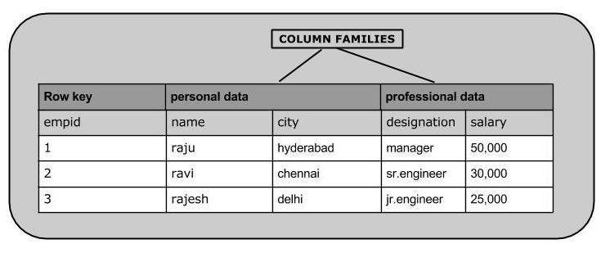

HBase Architecture
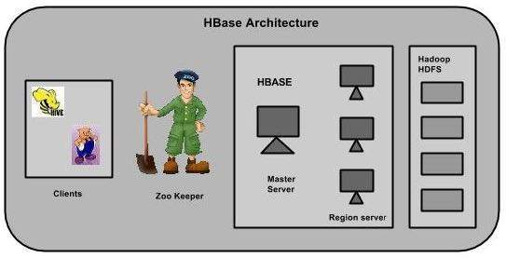
In HBase, tables are split into regions and are served by the region servers. Regions are vertically divided by column families into “Stores”. Stores are saved as files in HDFS. Shown below is the architecture of HBase.
HBase has three major components: the client library, a master server, and region servers. Region servers can be added or removed as per requirement.

Zookeeper Installation :
ZooKeeper server is created in Java and it runs on JVM. You need to use JDK. Now, follow the steps given below to install ZooKeeper framework on your machine.
We believe you already have a Java environment installed on your system. Just verify it using the following command.
$ java –version
If you have Java installed on your machine, then you could see the version of installed Java. Otherwise, follow the simple steps given above to install the latest version of Java.
Step 1
Download Zookeeper :
wget "http://www-eu.apache.org/dist/zookeeper/zookeeper-3.4.6/zookeeper-3.4.6.tar.gz"

Step 2
Generally you will find the downloaded file in Downloads folder. Verify it and extract the zookeeper-3.4.6.tar.gz file using the following commands.
$ tar –xzf zookeeper-3.4.6.tar.gz

Step 3
To make zookeeper available to all the users, you have to move it to the location “/usr/local/” and create a data directory under zookeeper.Open root, and type the following commands.
$ su
password:
$ mv zookeeper-3.4.6 /usr/local/zookeeper/
$ cd /usr/local/zookeeper
$ mkdir data

Step 4
Open the configuration file named zookeeper/conf/zoo.cfg using the command vi zoo.cfg and all the following parameters to set as starting point.
You have to duplicate zoo_sample.cfg file and make a zoo.cfg .
$ cd /usr/local/zookeeper
$ cp zoo_sample.cfg zoo.cfg
$ vi conf/zoo.cfg
tickTime = 2000
dataDir = /usr/local/zookeeper/data
clientPort = 2181
initLimit = 5
syncLimit = 2
Once the configuration file has been saved successfully, return to the terminal again. You can now start the zookeeper server.

Start Zookeeper Server
Start ZooKeeper server and execute the following command
$ bin/zkServer.sh start

After executing this command, you will get a response as follows
JMX enabled by default
Using config: /Users/../zookeeper-3.4.6/bin/../conf/zoo.cfg
Starting zookeeper ... STARTED

Stop ZooKeeper Server
After connecting the server and performing all the operations, you can stop the zookeeper server by using the following command $zkServer.sh stop

HBase Installation :
Step 1
Download Hbase :
wget "https://archive.apache.org/dist/hbase/1.1.2/hbase-1.1.2-bin.tar.gz"

Step 2
Generally you will find the downloaded file in Downloads folder. Verify it and extract the hbase-1.1.2-bin.tar.gz file using the following commands.
$ tar –xzf hbase-1.1.2-bin.tar.gz

Step 3
To make hbase available to all the users, you have to move it to the location “/usr/local/”.Open root, and type the following commands.
$ su
password:
$ mv hbase-1.1.2-bin /usr/local/hbase/
Step 4
For setting up PATH and HBASE_HOME variables, add the following commands to ~/.bashrc file.
export HBASE_HOME=/usr/local/hbase
export PATH=$PATH:$HBASE_HOME/bin

Now apply all the changes into the current running system.
$ source ~/.bashrc

Step 5
Set the Java Home for HBase and open /usr/local/hbase/conf/hbase-env.sh file:
export JAVA_HOME=/usr/local/jdk1.8
export HBASE_REGIONSERVERS=${HBASE_HOME}/conf/regionservers
export HBASE_MANAGES_ZK=true

A distributed Apache HBase installation depends on a running ZooKeeper cluster. All participating nodes and clients need to be able to access the running ZooKeeper ensemble.
Apache HBase by default manages a ZooKeeper "cluster" for us. It will start and stop the ZooKeeper ensemble as part of the HBase start/stop process. We can also manage the ZooKeeper ensemble independent of HBase and just point HBase at the cluster it should use.
To toggle HBase management of ZooKeeper, we can use the HBASE_MANAGES_ZK variable in conf/hbase-env.sh. This variable, which defaults to true, tells HBase whether to start/stop the ZooKeeper ensemble servers as part of HBase start/stop, which is the setup in this tutorial.
Step 6
usr/local/hbase/conf/hbase-site.xml is the main HBase configuration file. We only need to specify the directory on the local filesystem where HBase and ZooKeeper write data

<configuration>
<property>
<name>hbase.rootdir</name>
<value>hdfs://localhost:9000/hbase</value>
</property>

<property>
<name>hbase.cluster.distributed</name>
<value>true</value>
</property>

<property>
<name>hbase.zookeeper.property.clientPort</name>
<value>2181</value>
</property>

<property>
<name>hbase.zookeeper.property.dataDir</name>
<value>/usr/local/zookeeper/data</value>
</property>
</configuration>

We opted to have HBase manage a ZooKeeper quorum which is bound to port 2181. Note that we set HBASE_MANAGE_ZK to true in conf/hbase-env.sh. We should also set hbase.zookeeper.property.dataDir to other than the default as the default has ZooKeeper persist data under /tmp which is often cleared on system restart. In our configuration above, we have ZooKeeper persist to /user/local/zookeeper/data.

Starting HBase
With the setup in the preceeding sections, the HBase installation and configuration part is successfully complete. We can start HBase by using start-hbase.sh script provided in the bin folder of HBase.
Before starting HBase, we need to make sure Hadoop is running.
We can start HBase by using start-hbase.sh script provided in the bin folder of HBase:

$ start-hbase.sh
localhost: starting zookeeper, logging to /usr/local/hbase/bin/../logs/hbase-hduser-zookeeper-laptop.out
starting master, logging to /usr/local/hbase/logs/hbase-hduser-master-laptop.out
starting regionserver, logging to /usr/local/hbase/logs/hbase-hduser-1-regionserver-laptop.out

If our system is configured correctly, the jps command should show the HMaster and HRegionServer processes running:

$ jps
19296 DataNode
19185 NameNode
19937 NodeManager
32034 HQuorumPeer
32178 HRegionServer
19494 SecondaryNameNode
32091 HMaster
32606 Jps
19823 ResourceManager

We can also see HQuorumPeer which is HBase's version of ZooKeeper's QuorumPeer is also running. Since we let HBase manage ZooKeeper, HQuorumPeer is used to start up QuorumPeer instances. By doing things in here rather than directly calling to ZooKeeper, we have more control over the process.

HBase Shell
We can use the HBase Shell to create a table, populate it with data, scan and get values from it.

$ hbase shell
SLF4J: Class path contains multiple SLF4J bindings.
SLF4J: Found binding in [jar:file:/usr/local/hbase/lib/slf4j-log4j12-1.7.5.jar!/org/slf4j/impl/StaticLoggerBinder.class]
SLF4J: Found binding in [jar:file:/usr/local/hadoop/share/hadoop/common/lib/slf4j-log4j12-1.7.5.jar!/org/slf4j/impl/StaticLoggerBinder.class] SLF4J: See http://www.slf4j.org/codes.html#multiple_bindings for an explanation. SLF4J: Actual binding is of type [org.slf4j.impl.Log4jLoggerFactory]
HBase Shell; enter 'help<RETURN>' for list of supported commands.
Type "exit<RETURN>" to leave the HBase Shell
Version 1.2.4, r67592f3d062743907f8c5ae00dbbe1ae4f69e5af, Tue Oct 25 18:10:20 CDT 2016

hbase(main):001:0>

HBase Commands :
-- List
hbase> list 'test'
-- TABLE
-- test

-- Put
hbase> put 'test', 'row1', 'cf:a', 'value1'

hbase> put 'test', 'row2', 'cf:b', 'value2'

hbase> put 'test', 'row3', 'cf:c', 'value3'
-- Scan
hbase> scan 'test'

-- Get
hbase> get 'test', 'row1'

-- Disable
hbase> disable 'test'

hbase> enable 'test'

-- Drop
hbase> drop 'test'

- Sqoop 1.4.6
Sqoop − “SQL to Hadoop and Hadoop to SQL”
Sqoop is a tool designed to transfer data between Hadoop and relational database servers. It is used to import data from relational databases such as MySQL, Oracle to Hadoop HDFS, and export from Hadoop file system to relational databases. It is provided by the Apache Software Foundation.

Sqoop Architecture :
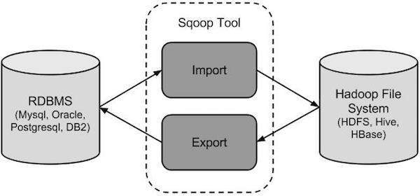
The following image describes the workflow of Sqoop.

Sqoop Import
The import tool imports individual tables from RDBMS to HDFS. Each row in a table is treated as a record in HDFS. All records are stored as text data in text files or as binary data in Avro and Sequence files.
Sqoop Export
The export tool exports a set of files from HDFS back to an RDBMS. The files given as input to Sqoop contain records, which are called as rows in table. Those are read and parsed into a set of records and delimited with user-specified delimiter.

Sqoop Installation :
Step 1
Download Sqoop :
$ wget "http://www-eu.apache.org/dist/sqoop/1.4.6/sqoop-1.4.6.bin__hadoop-2.0.4-alpha.tar.gz"

Step 2
Generally you will find the downloaded file in Downloads folder. Verify it and extract the sqoop-1.4.6.tar.gz file using the following commands.
$ tar –xzf sqoop-1.4.6.tar.gz

Step 3
To make hive available to all the users, you have to move it to the location “/usr/local/”. Open root, and type the following commands.
$ mv sqoop-1.4.6 /usr/local/sqoop/

Step 4
Open ~/.bashrc and set the environment variable SQOOP_HOME to point to the installation directory and PATH:
export SQOOP_HOME=/usr/local/sqoop
export PATH=$PATH :$SQOOP_HOME /bin
Now apply all the changes into the current running system.
$ source ~/.bashrc

Step 5
To configure Sqoop with Hadoop, you need to edit the sqoop-env.sh file, which is placed in the $SQOOP_HOME/conf directory. First of all, Redirect to Sqoop config directory and copy the template file using the following command:

$ cd $SQOOP_HOME/conf
$ mv sqoop-env-template.sh sqoop-env.sh

Open sqoop-env.sh and edit the following lines:

export HADOOP_COMMON_HOME=/usr/local/hadoop
export HADOOP_MAPRED_HOME=/usr/local/hadoop

Step 6
Download and Configure mysql-connector-java We can download mysql-connector-java-5.1.42.tar.gz file from the following link. The following commands are used to extract mysql-connector-java tarball and move mysql-connector-java-5.1.42-bin.jar to /usr/local/sqoop/lib directory

$ wget "http://ftp.ntu.edu.tw/MySQL/Downloads/Connector-J/mysql-connector-java-5.1.42.tar.gz"

$ tar -xzf mysql-connector-java-5.1.42.tar.gz
$ cd mysql-connector-java-5.1.42
$ cp mysql-connector-java-5.1.42-bin.jar /usr/local/sqoop/lib/

To check if the sqoop has been installed successfully type the command
$ sqoop version

17/08/29 17:25:19 INFO sqoop.Sqoop: Running Sqoop version: 1.4.6
Sqoop 1.4.6
git commit id c0c5a81723759fa575844a0a1eae8f510fa32c25
Compiled by root on Mon Apr 27 14:26:52 CST 2015

Mysql Install :
We choose to work with mysql as a database to run the data ingestion (import/export) in sqoop.
First, MySQL was replaced by MariaDB since Fedora 19 .

To install MariaDB Server you have to execute the following command:
$ yum install mariadb mariadb-server

To start MariaDB, execute the following command:
$ systemctl start mariadb.service

To autostart MariaDB, execute the following command:
$ systemctl enable mariadb.service

After you started MariaDB (do this only once), execute the following command:
$ /usr/bin/mysql_secure_installation

This command will ask you some inputs to set root password, remove anonymous users, disallow root login remotely, remove test database and reload privilege tables.

To check the status of MySQL/MariaDB
$ systemctl status mariadb

To stop MySQL/MariaDB:
$ systemctl stop mariadb

Check the installation with the command client and enter your password that you already set after executing the $ /usr/bin/mysql_secure_installation :

$ mysql – p
Welcome to the MariaDB monitor. Commands end with ; or \g.
Your MariaDB connection id is 3
Server version: 5.5.40-MariaDB MariaDB Server
Copyright (c) 2000, 2014, Oracle, Monty Program Ab and others.
Type 'help;' or '\h' for help. Type '\c' to clear the current input statement.
MariaDB [(none)]>

If you see that MySQL is active and running like in the screenshot above, it means that you have successfully installed and started MySQL on your server.

Sqoop Commands :
Now we will try to perform some sqoop commands I will be using the mysql database to perform the import and export sqoop commands :
MariaDB [mysql]> show databases;
+--------------------+
| Database |
+--------------------+
| information_schema |
| mysql |
| performance_schema |
| test |
+--------------------+
4 rows in set (0.00 sec)

MariaDB [mysql]> use mysql;
Database changed

MariaDB [mysql]> show tables;
+---------------------------+
| Tables_in_mysql |
+---------------------------+
| columns_priv |
| db |
| event |
| func |
| general_log |
| help_category |
| help_keyword |
| help_relation |
| help_topic |
| host |
| ndb_binlog_index |
| plugin |
| proc |
| procs_priv |
| proxies_priv |
| servers |
| slow_log |
| tables_priv |
| time_zone |
| time_zone_leap_second |
| time_zone_name |
| time_zone_transition |
| time_zone_transition_type |
| user |
+---------------------------+
24 rows in set (0.00 sec)

● Import an entire table
sqoop import \
--connect jdbc:mysql://localhost:3306/mysql \
--username root \
--password root \
--table user

● Import subset of data
sqoop import \
--connect jdbc:mysql://localhost:3306/mysql \
--username root \
--password root \
--table user \
--where "User = 'root'"

● Compressing Imported data
sqoop import \
--connect jdbc:mysql://localhost:3306/mysql \
--username root \
--table user \
--compress \
--compression-codec org.apache.hadoop.io.compress.BZip2Codec

● Bulk Import
sqoop import \
--connect jdbc:mysql://localhost:3306/mysql \
--username root \
--table user \
--direct

● Importing all your table
sqoop import-all-tables \
--connect jdbc:mysql://localhost:3306/mysql \
--username root \
--password root

------- Export

● Exporting files under HDFS directory to a table
sqoop export \
--connect jdbc:mysql://localhost:3306/mysql \
--username root \
--password root \
--table user \
--export-dir user

● Batch Inserts Export
sqoop export \
--connect jdbc:mysql://localhost:3306/mysql \
--username root \
--password root \
--table user \
--export-dir user \
--batch

● Updating existing Data set
sqoop export \
--connect jdbc:mysql://localhost:3306/mysql \
--username root \
--password root \
--table user \
--update-key id

● Column Export
sqoop export \
--connect jdbc:mysql://localhost:3306/mysql \
--username root \
--password root \
--table user \
--columns User,Host

To check your tables are created under the HDFS execute the following command :
$ hadoop fs -ls /user/root/
Found 4 items
drwxr-xr-x - root supergroup 0 2017-09-04 11:27 /user/root/columns_priv
drwxr-xr-x - root supergroup 0 2017-09-04 11:27 /user/root/db
drwxr-xr-x - root supergroup 0 2017-09-04 11:27 /user/root/event
drwxr-xr-x - root supergroup 0 2017-09-04 11:28 /user/root/func

$ hadoop fs –cat /user/root/db/part-m-00000
part-m-00000

- Flume 1.5.2

Apache Flume is a tool/service/data ingestion mechanism for collecting aggregating and transporting large amounts of streaming data such as log files, events (etc...) from various sources to a centralized data store.
Flume is a highly reliable, distributed, and configurable tool. It is principally designed to copy streaming data (log data) from various web servers to HDFS.

Flume Architecture :
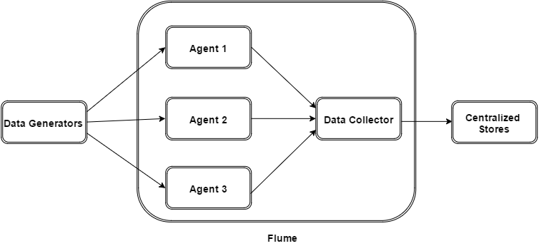
The following illustration depicts the basic architecture of Flume. As shown in the illustration, data generators (such as Facebook, Twitter) generate data which gets collected by individual Flume agents running on them. Thereafter, a data collector (which is also an agent) collects the data from the agents which is aggregated and pushed into a centralized store such as HDFS or HBase.

Flume Agent :
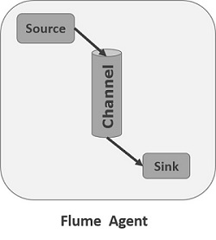
An agent is an independent daemon process (JVM) in Flume. It receives the data (events) from clients or other agents and forwards it to its next destination (sink or agent). Flume may have more than one agent. Following diagram represents a Flume Agent

Flume Installation :

Step 1
Download Flume :
wget "http://www-eu.apache.org/dist/flume/1.5.2/apache-flume-1.5.2-bin.tar.gz"

Step 2
Generally you will find the downloaded file in Downloads folder. Verify it and extract the apache-flume-1.5.2-bin.tar.gz file using the following commands.
$ tar –xzf apache-flume-1.5.2-bin.tar.gz

Step 3
To make hive available to all the users, you have to move it to the location “/usr/local/”. Open root, and type the following commands.
$ su
password:
$ mv apache-flume-1.5.2-bin /usr/local/flume/

Step 4
Open ~/.bashrc and set the environment variable FLUME_HOME to point to the installation directory and PATH:
export FLUME_HOME=/usr/local/flume
export PATH=$PATH :$FLUME_HOME /bin
export CLASSPATH=$CLASSPATH:$FLUME_HOME/lib/*
Now apply all the changes into the current running system.
$ source ~/.bashrc

Step 5
We need to edit the flume-env.sh file and the flume-conf.properties file, which are placed in the $FLUME_HOME/conf directory. First of all, Redirect to flume config directory and copy the template file using the following command:

$ cd $FLUME_HOME/conf
$ mv flume-env-template.sh flume-env.sh
$ mv flume-conf.properties.template flume-conf.properties

Open flume-env.sh and edit the following lines:

export JAVA_HOME=/usr/local/jdk1.8

Step 6
To check if the flume has been installed successfully type the command
$ flume-ng version

Flume 1.5.2
Source code repository: https://git-wip-us.apache.org/repos/asf/flume.git
Revision: 229442aa6835ee0faa17e3034bcab42754c460f5
Compiled by hshreedharan on Wed Nov 12 12:51:22 PST 2014
From source with checksum 837f81bd1e304a65fcaf8e5f692b3f18

Setup a Flume Agent :
Flume agent configuration is stored in a local configuration file. This is a text file that follows the Java properties file format. Configurations for one or more agents can be specified in the same configuration file. The configuration file includes properties of each source, sink and channel in an agent and how they are wired together to form data flows.
Single Agent Example
We will look at an example of the logger example and save it in HDFS and a memory channel.
# Source of an Agent with tail
agent.source = source_log-tail
agent.sources.source_log-tail.type = exec
agent.sources.source_log-tail.command = tail -F /log/logger.log
agent.sources.source_log-tail.channels = memoryChannel

# Sink of an Agent to save in HDFS
agent.sinks = log-hdfs
agent.sinks.log-hdfs.channel = memoryChannel
agent.sinks.log-hdfs.type = hdfs
agent.sinks.log-hdfs.hdfs.path = /log/logger.log

# Channel of an Agent to store in memory
agent.channels = memoryChannel
agent.channels.memoryChannel.type = memory
agent.channels.memoryChannel.capacity = 10000
agent.channels.memoryChannel.transactionCapacity = 10000
agent.channels.memoryChannel.byteCapacityBufferPercentage = 20
agent.channels.memoryChannel.byteCapacity = 800000

Start the flume process
$ flume-ng agent -n agent -c conf -f conf/flume-conf.properties -Dflume.root.logger=INFO,console

- Storm 0.10.0
Apache Storm is a distributed real-time big data-processing system. Storm is designed to process vast amount of data in a fault-tolerant and horizontal scalable method. It is a streaming data framework that has the capability of highest ingestion rates. Though Storm is stateless, it manages distributed environment and cluster state via Apache ZooKeeper. It is simple and you can execute all kinds of manipulations on real-time data in parallel.

Storm Architecture :
Physical Architecture :
One of the main highlight of the Apache Storm is that it is a fault-tolerant, fast with no “Single Point of Failure” (SPOF) distributed application. We can install Apache Storm in as many systems as needed to increase the capacity of the application.
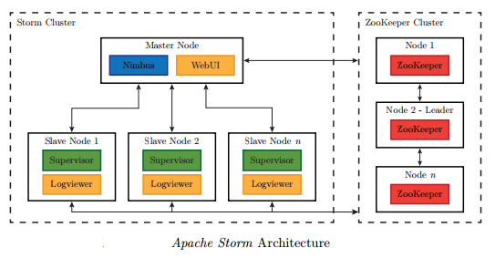

Logical Architecture :
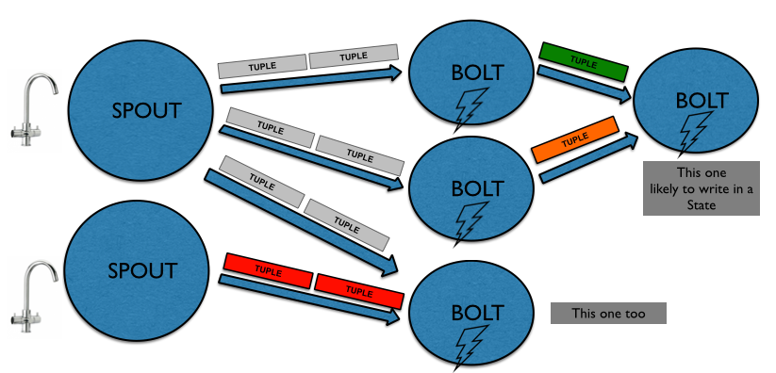
One of the main highlight of the Apache Storm is that it is a fault-tolerant, fast with no “Single Point of Failure” (SPOF) distributed application. We can install Apache Storm in as many systems as needed to increase the capacity of the application.

Storm Instalation :

Prerequisites
Let us now see how to install Apache Storm framework on your machine.
There are three majo steps here :
- Install Java on your system, if you don’t have it already.
- Install ZooKeeper framework.
- Install Apache Storm framework.

You can check above how to install Java and Zookeeper, so I assume that you already install them and I will begin with Storm installation.

Step 1
Download Storm :
wget "http://www-eu.apache.org/dist/storm/apache-storm-0.10.0/apache-storm-0.10.0.tar.gz"

Step 2
Generally you will find the downloaded file in Downloads folder. Verify it and extract the apache-storm-0.10.0.tar.gz file using the following commands.
$ tar –xzf apache-storm-0.10.0.tar.gz

Step 3
To make hive available to all the users, you have to move it to the location “/usr/local/”. Open root, and type the following commands.
$ su
password:
$ mv apache-storm-0.10.0 /usr/local/storm/

Step 4
Open ~/.bashrc and set the environment variable HIVE_HOME to point to the installation directory and PATH:
export STORM_HOME=/usr/local/storm
export PATH=$PATH :$STORM_HOME/bin
Now apply all the changes into the current running system.
$ source ~/.bashrc

Step 5
The current release of Storm contains a file at “conf/storm.yaml” that configures Storm daemons. Add the following information to that file

storm.zookeeper.servers:
- "127.0.0.1"
nimbus.host: "127.0.0.1”
storm.local.dir: "/home/username/storm/datadir/storm"
supervisor.slots.ports:
- 6700
- 6701
- 6702
- 6703
Then

Start ZooKeeper
$ zkServer.sh start

Start nimbus (start in separate shell or in background with &)
$ storm nimbus

Start supervisor (start in separate shell or in background with &)
$ storm supervisor

Apach Spark 2.2.0
Apache Spark is a lightning-fast cluster computing technology, designed for fast computation. It is based on Hadoop MapReduce and it extends the MapReduce model to efficiently use it for more types of computations, which includes interactive queries and stream processing. The main feature of Spark is its in-memory cluster computing that increases the processing speed of an application.
Spark is designed to cover a wide range of workloads such as batch applications, iterative algorithms, interactive queries and streaming. Apart from supporting all these workload in a respective system, it reduces the management burden of maintaining separate tools.

Spark Components :
The following illustration depicts the different components of Spark.
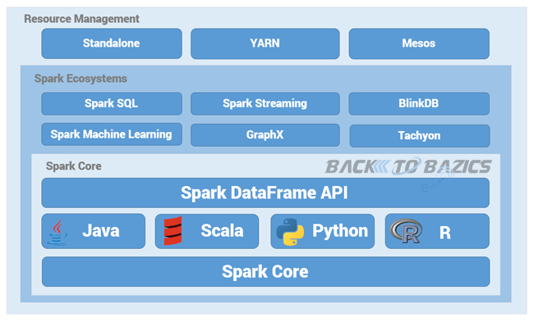

Spark Architecture :

Physical Architecture :
In general, Spark follows a master-slave architecture with a slightly different terminology. The master is called the driver, while slaves are referred to as executors.
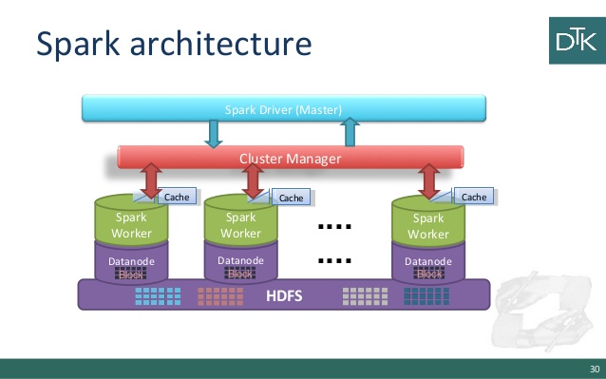
Logical Architecture :
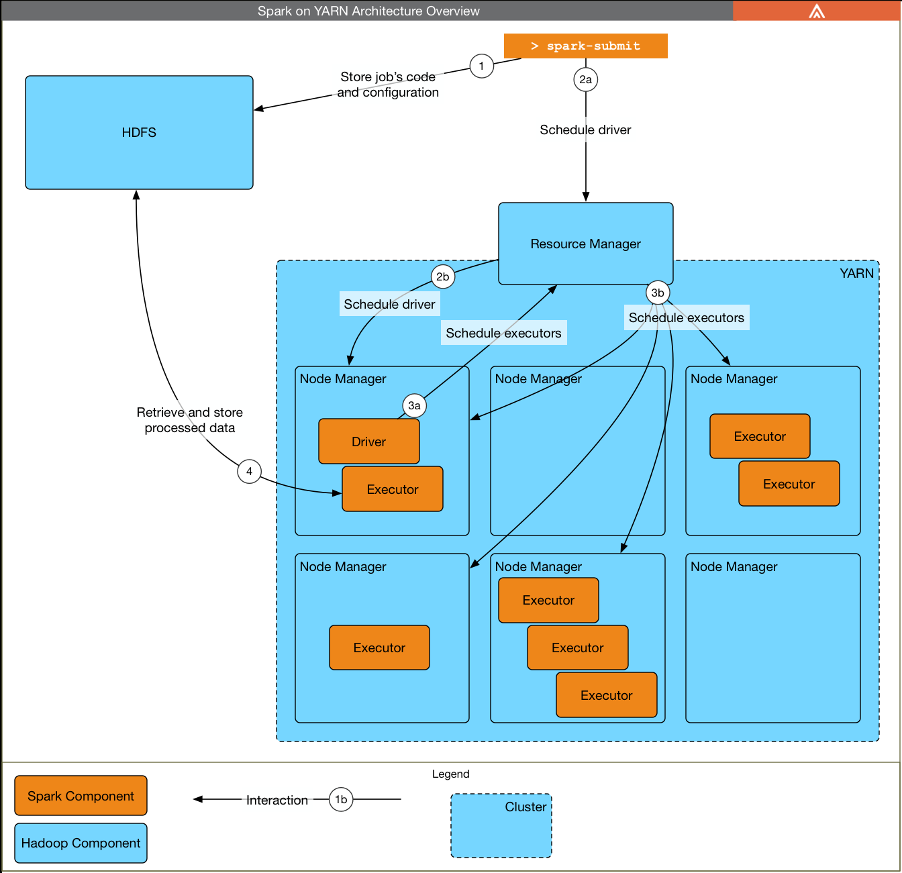

Spark Instalation :

This chapter explains the how to download, install, and set up Apache Spark in your system.
Prerequisites
It is essential that you have Java 1.7 and greater verion installed on your system before you go for Apache Spark.

Step 1:Verifying Java Installation
Java installation is one of the mandatory things in installing Spark. Try the following command to verify the JAVA version.
$java -version

In case you do not have Java installed on your system, then Install Java before proceeding to next step.

Step 2: Downloading Apache Spark
Download the latest version of Spark by visiting the following link Download Spark. For this tutorial, we are using spark-2.2.0-bin-hadoop2.7 version. After downloading it, you will find the Spark tar file in the download folder
$ wget "http://www-eu.apache.org/dist/spark/spark-2.2.0/spark-2.2.0-bin-hadoop2.7.tgz"

Step 3: Installing Spark
Follow the steps given below for installing Spark.
Extracting Spark tar
The following command for extracting the spark tar file.
$ tar xvf spark-1.3.1-bin-hadoop2.6.tgz

Moving Spark software files
The following commands for moving the Spark software files to respective directory (/usr/local/spark).
$ su –
Password:
# mv spark-2.2.0-bin-hadoop2.7 /usr/local/spark

Setting up the environment for Spark
Add the following line to ~/.bashrc file. It means adding the location, where the spark software file are located to the PATH variable.
export PATH = $PATH:/usr/local/spark/bin

Use the following command for sourcing the ~/.bashrc file.
$ source ~/.bashrc

Step 4: Verifying the Spark Installation
Write the following command for opening Spark shell.
$spark-shell

If spark is installed successfully then you will find the following output.
Using Spark's default log4j profile: org/apache/spark/log4j-defaults.properties
Setting default log level to "WARN".
To adjust logging level use sc.setLogLevel(newLevel). For SparkR, use setLogLevel(newLevel).
17/09/07 12:40:50 WARN NativeCodeLoader: Unable to load native-hadoop library for your platform... using builtin-java classes where applicable
17/09/07 12:40:51 WARN Utils: Your hostname, vps448506.ovh.net resolves to a loopback address: 127.0.0.1; using 51.254.206.35 instead (on interface eth0)
17/09/07 12:40:51 WARN Utils: Set SPARK_LOCAL_IP if you need to bind to another address
17/09/07 12:41:07 WARN ObjectStore: Failed to get database global_temp, returning NoSuchObjectException
Spark context Web UI available at http://51.254.206.35:4040
Spark context available as 'sc' (master = local[*], app id = local-1504780853516).
Spark session available as 'spark'.
Welcome to
____ __
/ __/__ ___ _____/ /__
_\ \/ _ \/ _ `/ __/ '_/
/___/ .__/\_,_/_/ /_/\_\ version 2.2.0
/_/

Using Scala version 2.11.8 (Java HotSpot(TM) 64-Bit Server VM, Java 1.8.0_144)
Type in expressions to have them evaluated.
Type :help for more information.

scala>

The Spark example : WordCount
You will find the wordCount example under the spark examples directory ‘/usr/local/spark/examples/src/main/java/org/apache/spark/examples/JavaWordCount.java’ and the JAR file that cotains the Java file under ‘/usr/local/spark/examples/jars/spark-examples_2.11-2.2.0.jar’
$ spark-submit --class org.apache.spark.examples.JavaWordCount \
--master local --deploy-mode client --executor-memory 1g \
--name wordcount --conf "spark.app.id=wordcount" \
/usr/local/spark/examples/jars/spark-examples_2.11-2.2.0.jar hdfs://localhost:9000/user/shiva/WCC.txt 2

The Result is :
appreciation: 1
influence: 3
whe: 3
is: 6
you: 1
a: 3
on: 3
You: 3
continue: 3
be: 3
creating: 1
have: 3
room: 1
will: 3
to: 3
: 5
learning,: 1
what's: 3
way.: 1
of: 1
Thank: 1
answr: 3
growing,: 1
enthusiasm: 1
....: 3
for: 4
great: 3
along: 1
an: 1
obvious: 9
making: 1
but: 3
and: 4
me.: 3
environment: 1
less: 6
mistakes: 1

